FREE WEBINAR
The (re)Purpose of Food: Reducing Food Waste at Home
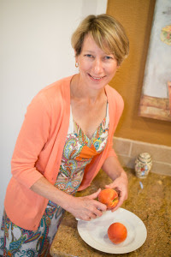
Nearly one third of the food we purchase ends up in the trash. This food waste stems from a variety of reasons: we bought food for a specific recipe and have some remaining, we ate out rather than cooked, we forgot we had it, or we think the food is almost too old to use or repurpose.
Regardless of why, the loss in dollars and impact on the environment add up. Conserving food is part of our history. In World War I, Americans were challenged to avoid wasting food as part of the war effort. Based on this conservation theme, this food-focused webinar highlights how we can use and eat food responsibly, such as "buy wisely, cook carefully, eat completely." From purchase to cooking, this session will address proper food storage, food solutions to maximize food use and minimize waste while maximizing nutrition.
Judy Barbe, an award winning registered dietitian, who will lead the webinar hosted by the Southeast Dairy Association, has been bringing realistic nutrition solutions to Mountain States tables since 1992. Judy is the founder of LiveBest, the immediate past chair of the Academy of Nutrition and Dietetics’ Food and Culinary Professionals Dietetic Practice Group, a spokesperson for the Wyoming Dietetic Association and has been recognized as Outstanding Dietitian. She is the author of Your 6-Week Guide to LiveBest, Simple Solutions for Fresh Food & Well-Being and LiveBest Seasonally, a Fresh Approach to Living with Vitality. She also is a long-time regional newspaper columnist, an experienced speaker and an avid traveler; she’s visited 26 countries and is planning a trip around the world.
Date: Thursday, August 4
11 a.m. - 12 p.m. CST / 12 - 1 p.m. EST
Objectives:
- Describe how food waste is generated throughout the food chain and the impact on the environment.
- Provide shopping, storage and preparation tips for people to efficiently use food.
- Deliver consumer-friendly messages about reducing food waste.
- Identify food donation priorities.
Register here by Wednesday, August 3.

