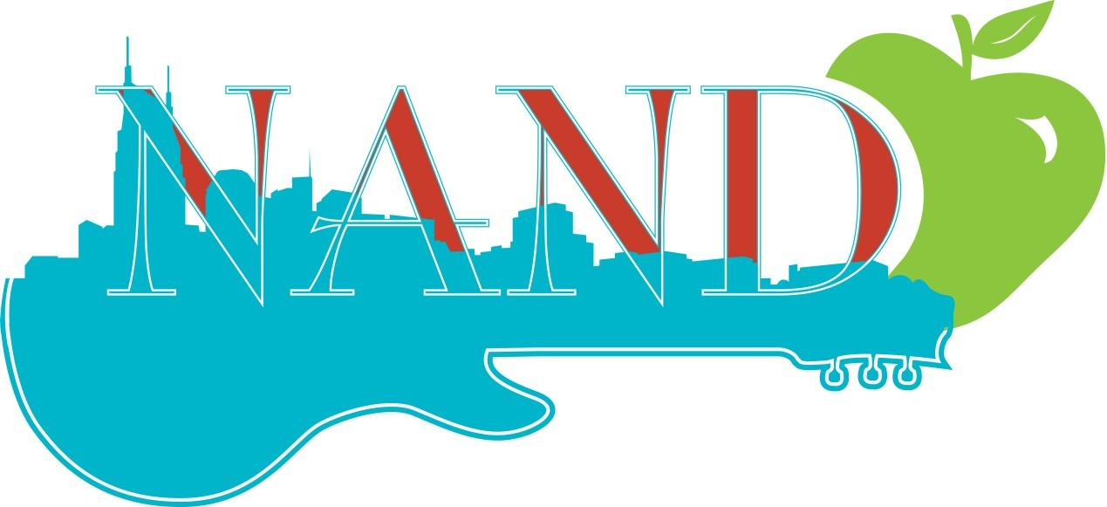

Nashville Academy of Nutrition and Dietetics
Fall Member Meeting: November 1, 2016 5:00-7:30 pm
Emma Bistro 11 Lea Avenue Nashville TN 37210
Meeting Agenda
5:00-5:30: Networking
5:30-5:40: Welcome to Meeting: President-Elect Emily Hogan
5:40-5:45: Sponsor Welcome
5:45-6:30: TAND Update: TAND President and Delegates:
Speakers: TAND President: Mary Catherine Schallert, TAND Delegates: Dee Harwell, Catherine Austin
· Objectives: Identify TAND strategic plan
· Objective: Updates from around the state including licensure law
6:30-7:30: Improving Your Private Practice to Meet Both Your Patient’s and Your Needs
Speakers: Nan Allison, MS, RD, LDN from Allison Nutrition Consulting
Debbie Farringer, Assistant Professor of Law, Belmont University
Joe Bennie, CPA, Promanagement

· Objective: Identify reasons for becoming a provider for insurance company
· Objective: Identify ways to protect yourself with a private practice and as a business owner
· Objective: Identify and manage any possible legal concerns in healthcare field
7:30-7:40: Closing Remarks
2 CEU hours available for NAND members, non-members will have a $10 charge for CEU’s.
There will be an opportunity to nominate your colleagues at this meeting. More details to come.

