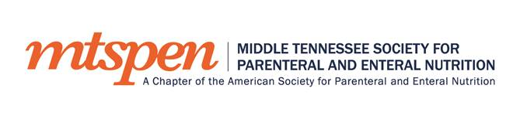AND
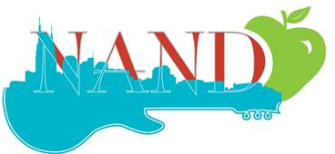

Present:

“Parenteral Nutrition (PN) Safety”
Speaker:
Dr. Carol Ireton-Jones

Tuesday, February 28, 2017
6:00 pm

Location: Maggiano’s Little Italy
3106 West End Avenue
Nashville, TN
Dinner is provided but not able to grant CEU credits

*RSVP is required, please send to Amanda Pinke at Amanda.pinke@fresenius-kabi.com or phone 205-213-3139.
The objectives for the presentation are to:
- Provide an overview of PN and address the safety concerns linked to it
- Review the newest PN safety clinical guidelines and consensus recommendations
- Discuss the role of standardization in helping improve the PN process
- Discuss the role commercially available multi-chamber PN bags can play in improving PN safety

After the Dr. Ireton-Jones' presentation, NAND will present their annual awards including intern recognition.

